**A PROJECT REPORT**

**on**

**“Detecting COVID-19 from X-Ray using Convolutional Neural Network (CNN)”**

**Submitted to**

**KIIT Deemed to be University**

**In Partial Fulfillment of the Requirement for the Award of BACHELOR’S DEGREE IN**

**INFORMATION TECHNOLOGY**

**BY**

|  |  |
| --- | --- |
| **Pratyush Kumar** | **1906188** |



**SCHOOL OF COMPUTER ENGINEERING**

**KALINGA INSTITUTE OF INDUSTRIAL TECHNOLOGY**

**BHUBANESWAR, ODISHA - 751024 Sept 2022**

A PROJECT REPORT

on

“Detecting COVID-19 from X-Ray using Convolutional Neural Network (CNN)”

Submitted to

KIIT Deemed to be University

In Partial Fulfillment of the Requirement for the Award of

BACHELOR’S DEGREE IN

INFORMATION TECHNOLOGY

BY

|  |  |
| --- | --- |
| **Pratyush Kumar** | **1906188** |



SCHOOL OF COMPUTER ENGINEERING

KALINGA INSTITUTE OF INDUSTRIAL TECHNOLOGY

BHUBANESWAE, ODISHA -751024

Sept 2022

**ABSTRACT**

The COVID-19 epidemic continues to have a terrible impact on the worldwide population's health and well-being. Successful screening of infected individuals is a critical step in the fight against COVID-19, with radiological imaging employing chest radiography being one of the primary screening modalities.

This study aimed to automatically detect COVID‐19 using digital chest x‐ray images while maximizing the accuracy in detection using convolutional neural networks (CNN). The dataset consists of 196 Covid and 196 Normal chest X-ray images.

**Keywords:** X-rays, CNN, Covid -19, Machine Learning, Classification.

Contents

|  |  |  |  |
| --- | --- | --- | --- |
| 1 | Introduction | | 10 |
| 2 | Chapter 2 | | 11 |
|  |  | Literature Review | 11 |
|  | 2.1 | Basic Concepts | 11 |
| 3 | Problem Statement / Requirement Specifications | | 3 |
|  | 3.1 | Objective | 15 |
|  | 3.2 | Project Planning........................... | 15 |
|  | 3.3 | Project Analysis (SRS)................. | 15 |
|  | 3.4 | System Design ………………….. | 15 |
| 4 | Implementation | | 16 |
|  | 4.1 | Methodology / Proposal ........................... | 16 |
|  | 4.2 | Testing / Verification Plan ……………. | 17 |
|  | 4.3 | Result Analysis / Screenshots …………. | 17 |
| 5 | Standard Adopted | | 18 |
|  | 5.1 | Design Standards . . . . . . . . . . . . . . . | 18 |
| 6 | Conclusion and Future Scope | | 19 |
|  | 6.1 | Conclusion ……………………….. | 19 |
|  | 6.2 | Future Scope ………………………. | 19 |
| References | | | 20 |
| Individual Contribution | | | 21 |
| Plagiarism Report | | | 25 |

List of Figures

Fig 1.1 Global Covid-19 10

Fig 2.2.1 RGB Image 11

Fig 2.2.2: Movement of the Kernel 12

Fig 2.2.3: Demonstration of Max pooling and Average Pooling 12

Fig 2.2.4: Fully Connected Network 13

Fig 2.2.5: Flattening 13

Fig 2.2.6: Droupout 14

Fig 2.2.7: ReLU Function 14

Fig 4.3.1: (i) Epochs vs Accuracy (ii) Epochs vs Loss 17

Fig 4.3.2: Confusion Matrix 18

Fig 5.1.1: Visualize Model 18

Chapter 1

Introduction

In December 2019, the coronavirus illness (COVID-19) pandemic broke out in Wuhan, China, and quickly spread around the world. Severe acute respiratory syndrome coronavirus-2 (SARS-CoV-2) is the virus that causes the COVID-19 epidemic disease. Coronaviruses (CoV) are a big virus family that causes diseases including Middle East Respiratory Syndrome (MERS-CoV) and Severe Acute Respiratory Syndrome (SARS) (SARS-CoV).

Infected people's tissues are damaged by COVID-19, which affects the lungs. Some people may not experience any symptoms in the early stages, but the majority of people experience fever and cough. Body pains, a sore throat, and a headache are all possibilities as subsequent symptoms.

COVID-19 illness is now on the rise due to a lack of early screening tools. In 2020, a large number of individuals perished from this sickness all across the world.

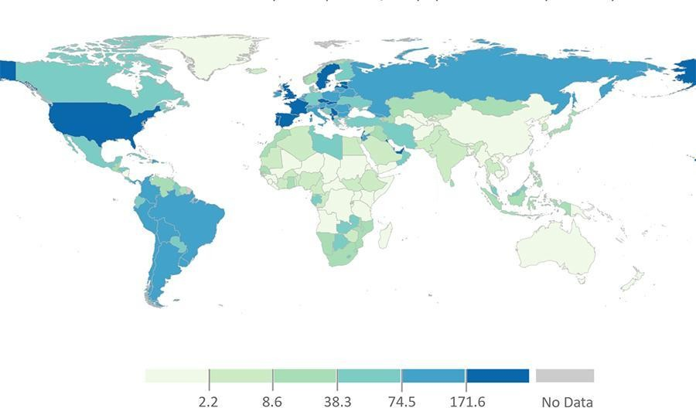

# Fig 1.1 Global Covid-19

The respiratory system and lungs are the easiest places for the virus to spread. Inflammation ensues, therefore, and air sacs can be filled with fluid and discharged. The procedure is responsible for obstructing oxygen uptake. In order to lower the fatality rate caused by this virus, doctors and health workers throughout the world must be able to diagnose it quickly and accurately.

Chest radiography (X-ray) is one of the most used ways to diagnose pneumonia across the world. A chest X-ray is a quick, low-cost, and widely used clinical procedure. In comparison to computed tomography (CT) and magnetic resonance imaging (MRI), a chest X-ray exposes *the* patient to less

radiation [11]. Making an accurate diagnosis from X-ray pictures, on the other hand, needs specialist knowledge and expertise. A chest X-ray is far more difficult to diagnose than other imaging modalities like CT or MRI.

The research presented here proposes an effective machine learning architecture for detecting COVID-19 disease from chest X-ray pictures.

Chapter 2

* 1. Literature Review

Researchers have used deep learning algorithms to examine chest X-ray pictures in order to detect COVID-19 in recent months. To extract better characteristics, the pictures are first pre-processed with the CNN method.

1. On chest CT scans, a DenseNet201-based deep transfer learning model was presented to identify patients as COVID-19 infected or non-infected.
2. Proposed a Deep model for early identification of COVID-19 patients using X-ray images with

98.08 percent and 87.02 percent accuracy for binary and multi-classes, respectively.

1. used ResNet-34 with an accuracy of 98.33%. They used the effectiveness of eight pre-trained Convolutional Neural Network (CNN) models such as AlexNet, VGG-16, GoogleNet, MobileNet-V2, SqueezeNet, ResNet-34, ResNet-50, and Inception-V3 for the classification of COVID-19 from normal cases
   1. Basic Concepts

A Convolutional Neural Network (CNN) is a Deep Learning system that can take an input picture, assign relevance (learnable weights and biases) to various aspects/objects in the image, and distinguish between them.

The mathematical function of convolution, which is a specific sort of linear operation in which two functions are multiplied to generate a third function that indicates how the shape of one function is affected by the other. In basic words, two matrices are multiplied to provide an output that is used to extract information from a picture.

**Input Image:**

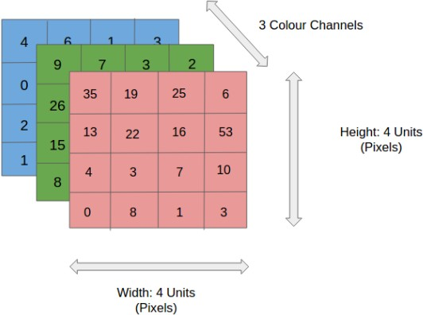We'll be using RGB photos for this project. RGB is a three-channel color system. An RGB picture has been divided into its three color planes — Red, Green, and Blue — as shown in the diagram.

# Fig 2.2.1 RGB Image

The CNN's job is to condense the pictures into a format that is easier to process while preserving elements that are important for a successful prediction. This is critical for designing an architecture that is capable of learning features while also being scalable to large datasets.

There are three types of layers that make up the CNN which are the convolutional layers, pooling layers, and fully connected (FC) layers. In addition to these three layers, there is two more important parameter which is the dropout layer and the activation function.

* + **Convolution Layers:**

This is the initial layer that extracts the different characteristics from the input photos. The

convolution mathematical operation is done between the input picture and a filter of a certain size MxM in this layer. The dot product between the filter and the sections of the input picture with

regard to the size of the filter is taken by sliding the filter across the input image (MxM).

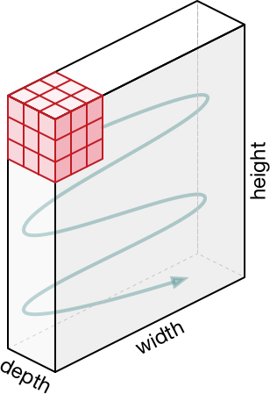

# Fig 2.2.2: Movement of the Kernel

* + **Pooling Layer:**

This layer's major goal is to lower the size of the convolved feature map in order to reduce

computational expenses. This is accomplished by reducing the connections between layers and operating independently on each feature map. There are numerous sorts of Pooling procedures, depending on the mechanism utilized.

In Max Pooling, the largest element is taken from the feature map. Average Pooling calculates the average of the elements in a predefined sized Image section.

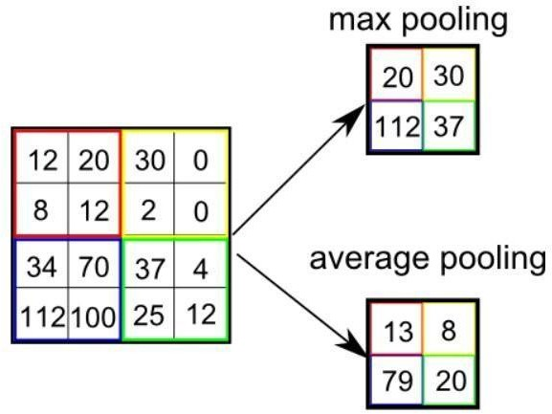

# Fig 2.2.3: Demonstration of Max pooling and Average Pooling

The Pooling Layer usually serves as a bridge between the Convolutional Layer and the FC Layer.

* **Fully Connected Network (FC)**

The Fully Connected (FC) layer connects the neurons between two layers by combining the weights and biases with the neurons. These layers are often placed before the output layer and make up the final few levels of a CNN Architecture.

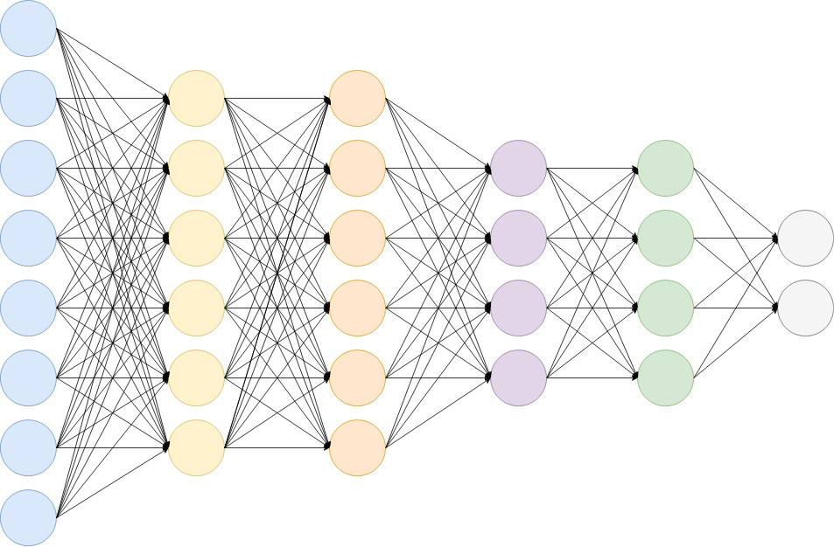

**Fig 2.2.4: Fully Connected Network**

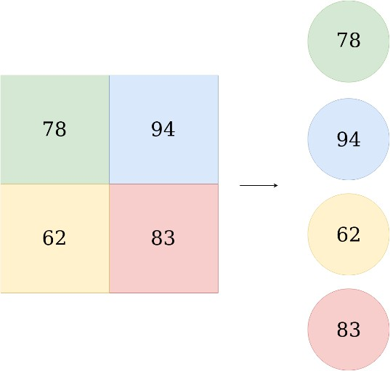The output from the final Pooling or Convolutional Layer, which is flattened and then fed into the fully connected layer, is the input to the fully connected layer.

# Fig 2.2.5: Flattening

* **Dropout:**

Overfitting happens when a model performs so well on training data that it has a detrimental influence on its performance when applied to fresh data.

To address this issue, a dropout layer is employed, in which a few neurons are removed from the neural network during the training process, resulting in a smaller model.

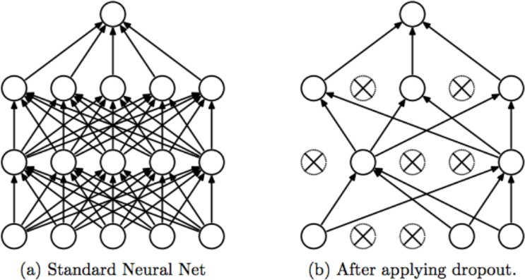

* **Activation Function**

**Fig 2.2.6: Dropout**

They're utilized to learn and approximate any form of network

variable-to-variable association that's both continuous and complicated.

It determines which model information should fire in the forward direction and which should not at the network's end.

In the project, we will be using The ReLU function. RELU layer will apply an elementwise activation function, such as the max(0,x) thresholding at zero. This leaves the size of the volume unchanged.

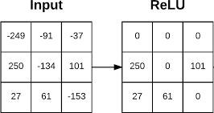

# Fig 2.2.7: ReLU Function

Chapter 3

Problem Statement / Requirement Specifications

* 1. **Objective**

One of the critical factors behind the rapid spread of the COVID-19 pandemic is the lengthy clinical testing time. The imaging tool, such as Chest X-ray (CXR), can speed up the identification process. We train and test our model to analyze the images as COVID or normal. The accuracy metrics are used to validate the classification of the model.

* 1. **Project Planning**
     1. Select programming language: Select the programming language you want to use for the implementation. The best implementation will be the use of Python for using standard libraries.
     2. Select Database: Selecting the database to implement the algorithm on. You can use Github or Kaggle.
     3. Select Algorithm: Select the algorithm that you want to implement from scratch. Be as specific as possible. This means not only the class, and type of algorithm, but also going as far as selecting a specific description or implementation that you want to implement.
     4. Select Problem: Select a problem or set of problems that we can use to test and validate your implementation of the algorithm.
     5. Research Algorithm: Locate papers, books, websites, libraries, and any other descriptions of the algorithm you can read and learn from. Although you ideally want to have one keystone description of the algorithm from which to work, you will want to have multiple perspectives on the algorithm. This is useful because the multiple perspectives will help you to internalize the algorithm description faster and overcome roadblocks from any ambiguities or

assumptions made in the description (there are always ambiguities in algorithm descriptions).

* + 1. Training the data: Training the algorithm to get a good result For our project we got an accuracy of 95%.
    2. Visualize the data:- After the implementation, the data needs to be visualized to the person. Graphs need to be plotted to show the accuracy and loss. To have a better understanding of the classification, a confusion matrix can also be plotted.
  1. **Project Analysis**

At first we need to collect our data, and make sure that is it 224x224 pixels. Followed by this,

different functions such as Convolution, max-pooling, etc are applied to the dataset. The dataset is trained from scratch and the image is rescaled. Dataset is checked and accuracy is observed.

* 1. **System Design**

**3.4.1 Design Constraints**

The software used during the projects and IDE you can prefer:

1. Windows terminal
2. Visual Studio Code

Chapter 4 Implementation

* 1. Methodology OR Proposal
* Selection of libraries:
  + For implementing the method we will be using the following library:
    1. Tensorflow: create Deep Learning models directly or by using wrapper libraries that simplify the process.
    2. from keras.layers import * : to build the various layers. Keras layers are the building blocks of the Keras library that can be stacked together just like legos for creating neural network models.
    3. from keras.models import * : groups layers into an object with training and inference features.
    4. from keras.preprocessing import image : to generate batches of tensor image data with real-time data augmentation.
    5. visualkeras.layered_view(model): visualization of deep learning model.
* Applying the layers on the model
  + INPUT [224x224x3] will hold the raw pixel values of the image, in this case an image of width 224, height 224, and with three color channels R, G, B.
  + CONV layer will compute the output of neurons that are connected to local regions in the input, each computing a dot product between their weights and a small region they are connected to in the input volume. This may result in volume such as [224x224x32] since we are using 32 filters.
  + RELU layer will apply an elementwise activation function, such as the max(0,x) thresholding at zero. This leaves the size of the volume unchanged.
  + POOL layer will perform a downsampling operation along the spatial dimensions (width, height), resulting in volume.
  + FC (i.e. fully connected) layer will compute the class scores, resulting in a volume of size.
  + The process is repeated with various filter sizes.
* Training the dataset:
  + Augmentation is done on the data. The image is rescaled by a factor of 1/255 which will help in normalization. Sheer augmentation and zoon augmentation is added that will help to take random crops from the images. The horizontal_flip is set to be true since it will only add more variations and help in fighting to overfitting as well.
  + On the test data we will not apply any augmentation, we will only rescale it. Classification is set to be binary.
  1. Testing OR Verification Plan

|  |  |  |  |  |
| --- | --- | --- | --- | --- |
| Test ID | Test Case Title | Test Condition | System Behavior | Expected Result |
| T01 | Accuracy | Check on test data | 95% | Above 90% |

* 1. 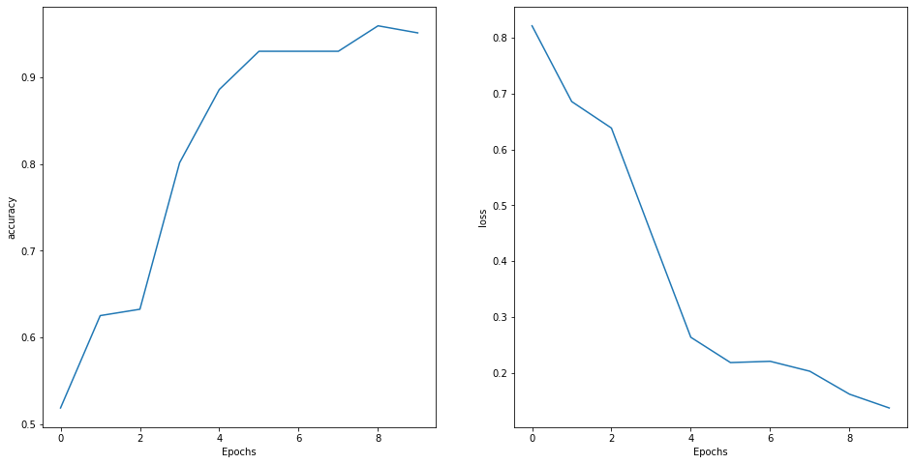Result Analysis OR Screenshots

# Fig 4.3.1: (i) Epochs vs Accuracy (ii) Epochs vs Loss

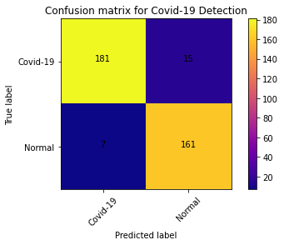

# Fig 4.3.2: Confusion Matrix

Chapter 5 Standards Adopted

5.1 Design Standards

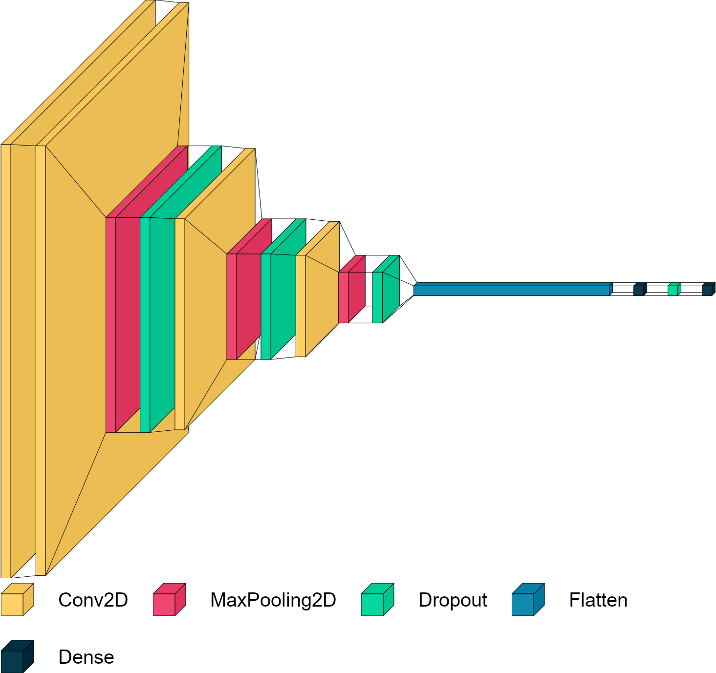

# Fig 5.1.1: Visualize Model

Chapter 6

Conclusion and Future Scope

* 1. Conclusion

It was found that the accuracy was greater than 95% for most of the cases. As seen in the confusion matrix, the model was able to classify if the particular x-ray is covid positive or not with a minimal error of 3% (Covid-19) and 7% (Normal).

* 1. Future Scope

●

Implementing Grad-CAM: on the dataset.

* + - Adding a user interface to predict the dataset instantly.
    - Adding more variety of diseases that can be predicted using X-rays.

***References***

1. Narin, A., Kaya, C. & Pamuk, Z. Automatic detection of coronavirus disease (COVID-19) using X-ray

images and deep convolutional neural networks. *Pattern Anal Applic* **24,** 1207–1220 (2021).

<https://doi.org/10.1007/s10044-021-00984-y>

1. Tulin Ozturk, Muhammed Talo, Eylul Azra Yildirim, Ulas Baran Baloglu, Ozal Yildirim, U. Rajendra

Acharya,

Automated detection of COVID-19 cases using deep neural networks with X-ray images, Computers in

Biology and Medicine.

1. Nayak, S. R., Nayak, D. R., Sinha, U., Arora, V., & Pachori, R. B. (2021). Application of deep learning

techniques for detection of COVID-19 cases using chest X-ray images: A comprehensive study. Biomedical

signal processing and control, 64, 102365. https://doi.org/10.1016/j.bspc.2020.102365

**SAMPLE INDIVIDUAL CONTRIBUTION REPORT:**

**Detecting COVID-19 from X-Ray using Convolutional Neural Network (CNN)**

SMRITI PANDEY

1906639

**Abstract:** The aim is to automatically detect COVID‐19 using digital chest x‐ray images while maximizing the accuracy in detection using convolutional neural networks (CNN) while using a dataset consists of 196 Covid and 196 Normal chest X-ray images and getting an accuracy greater than 95%.

**Individual contribution and findings:** I was responsible for going through the research papers and getting the idea of the model. I was involving the development if the code, finding the data, and getting the accuracy for the project. I was also involved in the visualization of the code as well.

**Individual contribution to project report preparation:** I contributed to making the report for the Minor Project.

**Individual contribution for project presentation and demonstration:** I was responsible to explain the introduction of CNN as well as the output generated by the model.

Full Signature of Supervisor: Full signature of the student:

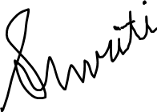

……………………………. ……………………………..

**SAMPLE INDIVIDUAL CONTRIBUTION REPORT:**

**Detecting COVID-19 from X-Ray using Convolutional Neural Network (CNN)**

ADITI BARNWAL

1906008

**Abstract:** The aim is to automatically detect COVID‐19 using digital chest x‐ray images while maximizing the accuracy in detection using convolutional neural networks (CNN) while using a dataset consists of 196 Covid and 196 Normal chest X-ray images and getting an accuracy greater than 95%.

**Individual contribution and findings:** I got the idea of developing the project on this topic and then worked on research papers and helped my members in writing code. And I was also accountable for testing the code.

**Individual contribution to project report preparation:**I contributed to the RCB image and Relu function research and wrote the project planning, System design, testing and analysis.

**Individual contribution for project presentation and demonstration:** I will be explaining the layers of a convolution neural network(CNN)-The convolutional layer, Pooling layer, and Fully connected network.

Full Signature of Supervisor: Full signature of the student:



……………………………. …………………………..

**SAMPLE INDIVIDUAL CONTRIBUTION REPORT:**

**Detecting COVID-19 from X-Ray using Convolutional Neural Network (CNN)**

ANANYA MOHANTY 1906231

**Abstract:** The aim is to automatically detect COVID‐19 using digital chest x‐ray images while maximizing the accuracy in detection using convolutional neural networks (CNN) while using a dataset consists of 196 Covid and 196 Normal chest X-ray images and getting an accuracy greater than 95%.

**Individual contribution and findings:** I contributed to the research for the data and image cases required to carry out tests. I also helped in testing the code.

**Individual contribution to project report preparation:** I wrote the conclusion, and i have done the editing required in this report.

**Individual contribution to project presentation and demonstration:** I contributed to developing the slides and explaining the objective and literature review.



Full Signature of Supervisor: Full signature of the student:

……………………………. ……………………………..

**SAMPLE INDIVIDUAL CONTRIBUTION REPORT:**

**Detecting COVID-19 from X-Ray using Convolutional Neural Network (CNN)**

ASHUTOSH SHARMA

1906467

**Abstract:** The aim is to automatically detect COVID‐19 using digital chest x‐ray images while maximizing the accuracy in detection using convolutional neural networks (CNN) while using a dataset consists of 196 Covid and 196 Normal chest X-ray images and getting an accuracy greater than 95%.

**Individual contribution and findings:** I worked on research papers and helped my members in writing the code and checking errors.

**Individual contribution to project report preparation:** I contributed to the research work of the report for the Minor Project.

**Individual contribution for project presentation and demonstration:** I was responsible for developing the contents of the slides and explaining ANN, RNN, and why CNN is a better alternative for image classification.

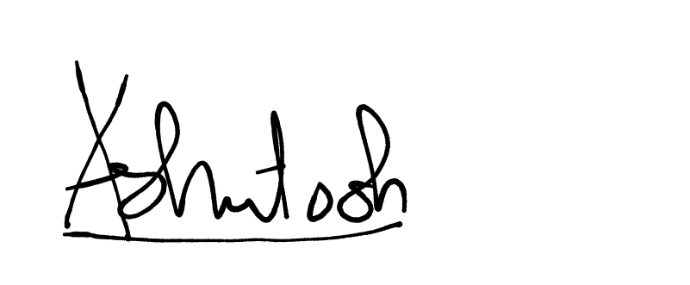

Full Signature of Supervisor: Full signature of the student:

……………………………. ……………………………..

TURNITIN PLAGIARISM REPORT

**(This report is mandatory for all the projects and plagiarism must be below 25%)**

